***1.INTRODUCION***

**1.1 OVERVIEWS**

***The election resulted in the landslide victory for he BJP which won 303 seats and formet he government. Around 912 million people were eligible to vote, and vote turnout was over 67 percent-the highest ever,as well as the hidhest ever participation by women votes***

**1.2 Purpose**

*Genaral Elecions were held in india in seven phases from*

*11April to 19May 2019 to elect theembers of the 17th lok sabha. votes were counted and the result was declared on 23May.The election resulted in a landslide victory for the BJP which won 303 seats and formed the government.*

**2.1 EMPATHY MAP**

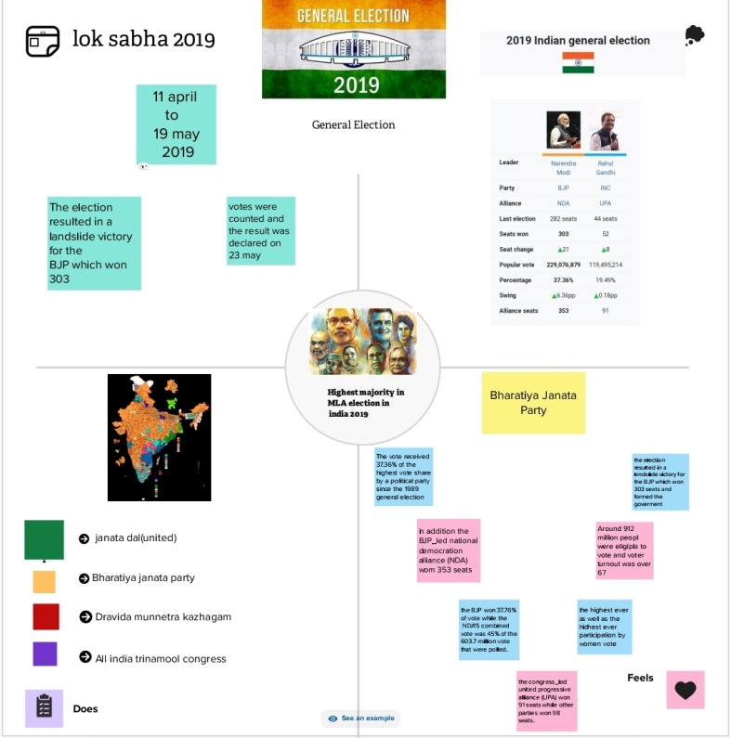

**2.2 BRAINSTROMING MAP**

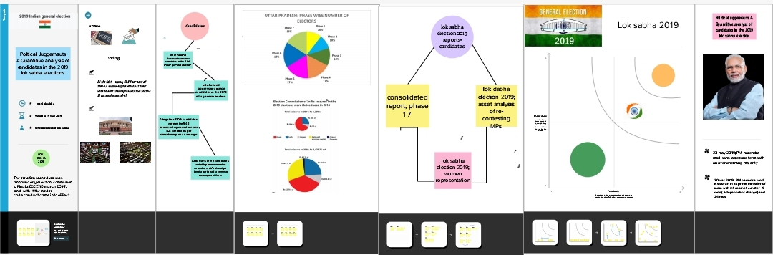

**RESULT**

*The election result in a landslide victory for the BJP which won 303 seats and formed the government.Around 912 million people were eligible to vote, and voter turnout was over 67percent  the highest ever,as well as the highest ever participation by women voters*

*1.which lok sabha was elected in 2019?*

*2.How many members are there in the lok sabha 2019?*

*3.what is the importance of the lok sabha?*

*4.how many members are there in lok sabha?*

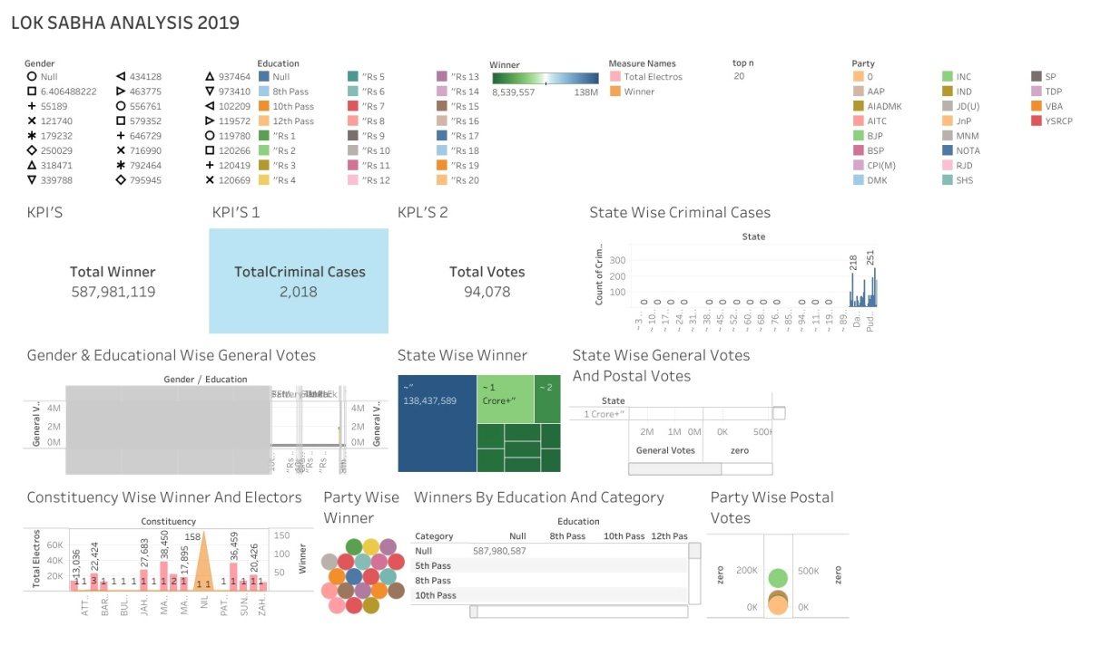

ADVANTAGES’

***It help in proper functioning of democracy through the system of checks and balances .no confidence motion can only be introduced and passed in the Lok sadha. so it controls the despotism of the government.money bills can be only introduced in he Lok sabha.***

***DISADVANTAGES***

***There is no disadvantage with the loksabha.there are some problem like disruption of the proceedings by congrees members and other members .some members never participate in the dedates and proceedings .there members should be admonished to be active in loksabha.***

***APPLICATIONS***

***The counting of votes will be conducted on 23rd may2019 and no same days the result will redeclared.trends and result will be on…***

***CONCLUSION***

***General election were held in india in seven phases from 1 april to 19may 2019 to elect the members of the 17th Lok sabha. votes were counted and the result was declared on 23 may.the election resulted in a landslid victory for the BJP which won 303 seats and formed the government.***

***FUTURE SCOPE***

* ***The elect members of the 17th Lok sabha***
* ***In india in seven phases from 11 april to 19 may 2019***
* ***leader of loksabha mariners modi Rahul Gandhi***
* ***last election 282 seats,44 seats***

*joiioipop*

